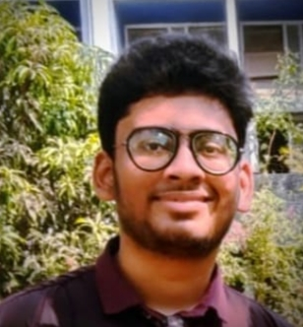

**Stalin Rodrigues**

# Flutter developer

**PROFILE**

**Email** [stalinrodrigues2004@gmail.com](mailto:stalinrodrigues2004@gmail.com) **Portfolio**

* [https://www.linkedin.com](http://www.linkedin.com/in/stalin-)

[/in/stalin-](http://www.linkedin.com/in/stalin-)rodrigues- 26b51a229

* https://github.com/StalinR odrigues

# Phone Number

9356774237

# Address

405, Isha Krupa, Pedi Goan, Nandakhal, Virar West, Near Carmel Convent school.

# Objective

I am a student at Bhausaheb Vartak Polytechnic, pursuing diploma in Computer Engineering. Currently looking for an internship to learn new skills and grow myself.

# Languages

* English
* Hindi
* Marathi

# Education

**Diploma in computer engineering | Bhausaheb Vartak Polytechnic**

* Sem 3: 86% | 10/03/2022
* Sem 2: 85% | 31/08/2022
* Sem 1: 91% | 16/04/2022 **Carmel Convent High School** SCC, March 2020

percentage: 76%

# Projects Fitness and gym

This is my very first website created using html and CSS, published on GitHub.com

https://stalinrodrigues.github.io/gym-website/

# Calculator app

Here I have created a simple calculator using switch statements in C++. https://github.com/StalinRodrigues/calculator-using-cpp

* **Skills** MS office

Java

Html

CSS

Leadership

Communication Skills

 **Hobbies** Watching Movies Volleyball Swimming

# Certifications

The Fundamentals of Digital marketing **Google, June 12, 2020**

Mastering The Art Of Effective Communication **upGrad, April 18 ,2022**

NATIONAL LEVEL QUIZ ON WEB PROGRAMMING USING HTML

**Thakur College, July 27, 2021** State Level Technical Poster presentation Competition **Pravin Patil, April 9, 2022**

# I hereby declare that the above information is correct to the best of my knowledge.

Date:05/07/22

 Place: Vasai Stalin Rodrigues

I